Convert Value Celsius into Fahrenheit in JavaScript

Source Code

<!DOCTYPE html>
<html>
<body>
<p>Convert celcius to faranheit value</p>
<p>Celcius Value:<input id="txtCelcius" onkeyup="convert('C')" /></p>
<p>Farenhit Value:<input id="txtFahrenhit" onkeyup="convert('F')" /></p>
<script>
function convert(degree) { var p;
if (degree == "C") {
p = (document.getElementById("txtCelcius").value * 9) / 5 + 32; document.getElementById("txtFahrenhit").value = Math.round(p);
} else {
p = ((document.getElementById("txtFahrenhit").value - 32) * 5) / 9; document.getElementById("txtCelcius").value = Math.round(p);
}
}
</script>
</body>
</html>

Output:

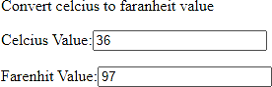

Results:

Thus, the above Program to Convert Value Celsius into Fahrenheit in JavaScript was executed successfully.
Implement getElementsByClassName() method in JavaScript

Source Code

<!DOCTYPE html>
<html>
<body>
<div class="myclass">The value is presented inside the class</div>
<button onclick="RetriveByClassName()" id="btnClick">Click</button>
<script>
function RetriveByClassName() {
var x = document.getElementsByClassName("myclass"); alert(x[0].innerHTML);
}
</script>
</body>

</html>

Output:

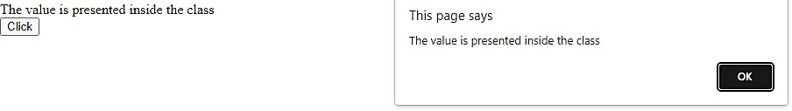

Results:

Thus, the above Program to Implement getElementsByClassName() method in JavaScript was executed successfully.

Install Node.JS

Step 1:
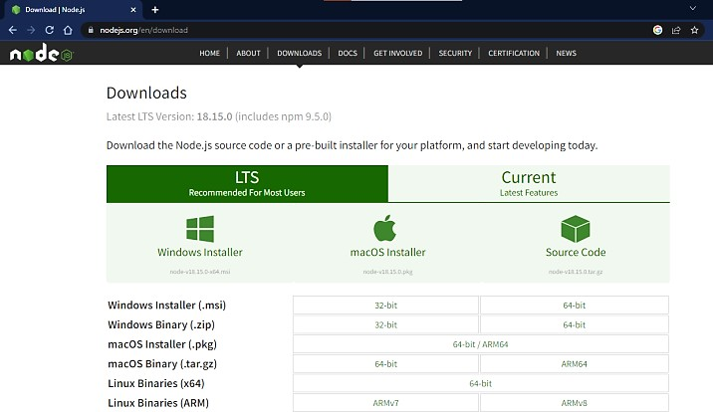

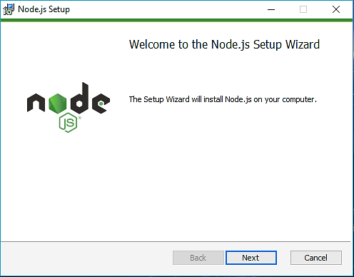
Step 2:

Step 3:
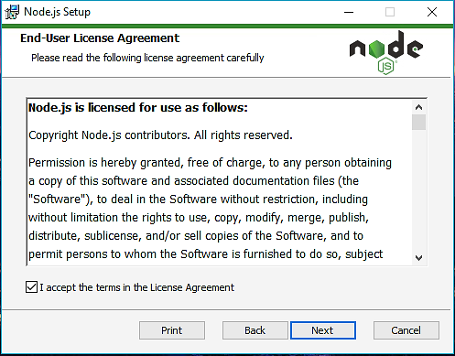

Step 4:
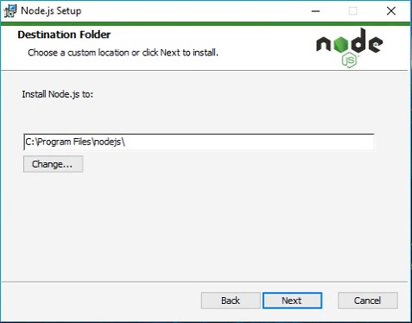

Step 5:
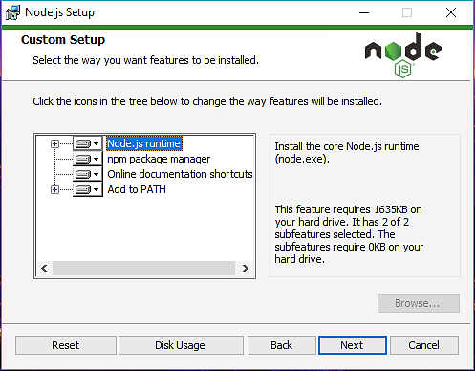
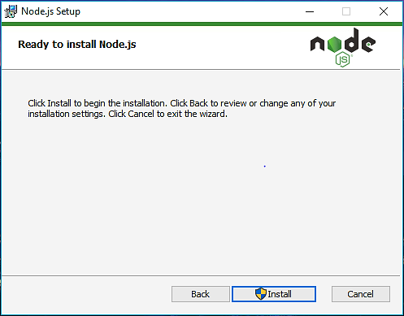

Step 6:

C:\Users\Admin> node –v
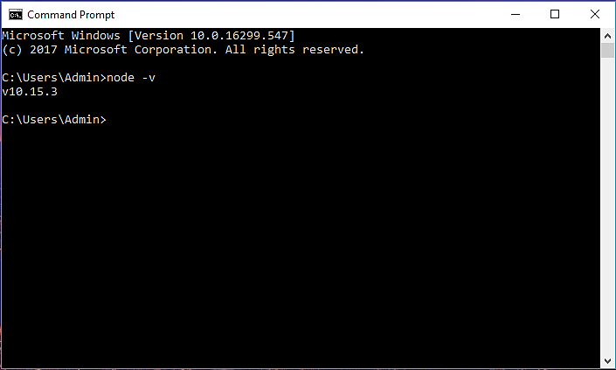

Results:

Thus, the above Program to Install Node.JS was installed successfully.
Create Web Server

Source Code:

httpWebServer.js

var http = require("http");
http
.createServer(function (req, res) { res.write("Hello World!"); res.end();
})
.listen(8080);

Output:
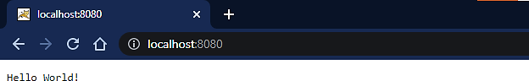

Results:

Thus, the above Program to Create Web Server was executed successfully.

Use NPM Command

>>npm init

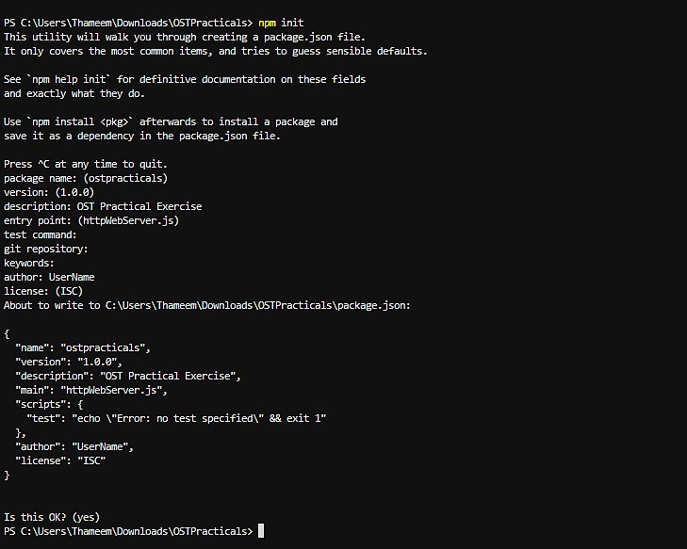

>>npm i express
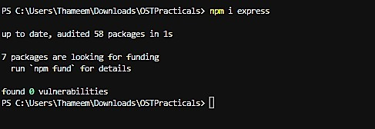

Output:
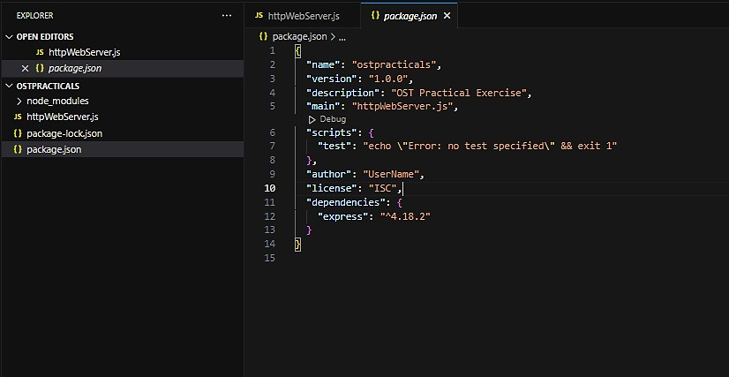

Results:

Thus, the above Program to Use NPM Command was executed successfully.
Retrieve Values using Express

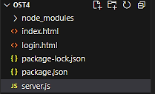
Folder Structure:

Source Code:
const express = require("express");

// Include ExpressJS
const app = express();

// Create an ExpressJS app
const bodyParser = require("body-parser");

// Middleware
app.use(bodyParser.urlencoded({ extended: false }));

// Route to Homepage
app.get("/", (req, res) => { res.sendFile( dirname + "/index.html"); });

// Route to Login Page
app.get("/login", (req, res) => { res.sendFile( dirname + "/login.html"); });
app.post("/login", (req, res) => {
// Insert Login Code Here
let username = req.body.username; let password = req.body.password;
res.send(`Username: ${username} Password: ${password}`);
});
const port = 3000; // Port we will listen on
// Function to listen on the port
app.listen(port, () => console.log(`This app is listening on port ${port}`
));

index.html:

<!DOCTYPE html>
<html lang="en">
<head>
<meta charset="UTF-8" />
<meta http-equiv="X-UA-Compatible" content="IE=edge" />
<meta name="viewport" content="width=device-width, initial-scale=1.0" />
<title>Welcome Page</title>
</head>
<body>
<a href="/login">Please Login Here!</a>
</body>
</html>

login.html:

<!DOCTYPE html>
<html lang="en">
<head>
<meta charset="UTF-8" />
<meta http-equiv="X-UA-Compatible" content="IE=edge" />
<meta name="viewport" content="width=device-width, initial-scale=1.0" />
<title>Login Page</title>
</head>
<body>
<form action="/login" method="post">
<!-- user input--> Username:<br />
<input
type="text" name="username" placeholder="Username" required
/><br /><br /> Password:<br />

<input
type="password" name="password" placeholder="Password" required
/><br /><br />
<!-- submit button -->
<input type="submit" value="login" />
</form>
</body>
</html>

Package.json:

{
"name": "ost4",
"version": "1.0.0",
"description": "OST practical Exercise 4", "main": "server.js",
"scripts": {
"test": "echo \"Error: no test specified\" && exit 1", "start": "node server.js"
},
"author": "",
"license": "ISC", "dependencies": {
"body-parser": "^1.20.2",
"express": "^4.18.2"
}
}

Output:


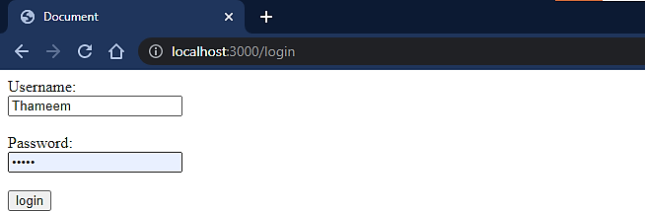
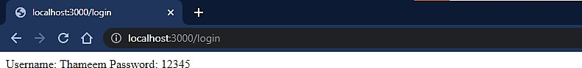

Results:

Thus, the above Program to Retrieve Values using Express was executed successfully.
Highlight Menu using Angular.js

Source code:

index.html
<!DOCTYPE html>
<html lang="en">
<head>
<meta charset="utf-8" />
<meta name="viewport" content="width=device-width, initial-scale=1.0" />
<link href="style.css" rel="stylesheet" />
<title>Document</title>
</head>
<body ng-app>
<nav class="{{active}}" ng-click="$event.preventDefault()">
<a href="#" class="home" ng-click="active='home'">Home</a>
<a href="#" class="about" ng-click="active='about'">About</a>
<a href="#" class="contact" ng-click="active='contact'">Contact</a>
</nav>
<p ng-show="active">You chose <b>{{active}}</b></p>
<script src="https://ajax.googleapis.com/ajax/libs/angularjs/1.0.7/angular.min.js"></s cript>
</body>
</html>

style.css
a:hover, a:focus, a:active {
text-decoration: none; color: inherit;
font-size: large;
}
nav {
display: inline-block; background-color: #55b460; border-radius: 4px;
}
nav.home.home, nav.team.team, nav.about.about, nav.contact.contact {
background-color: #a9aedd;
}

Output:

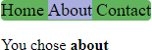

Results:

Thus, the above Program to Highlight Menu using Angular.js was executed successfully.

Manipulate Web Page using JQuery

Source Code:

index.html:

<!DOCTYPE html>
<html>
<head>
<script src="https://code.jquery.com/jquery-3.6.0.min.js"></script>
</head>
<body>
<h1 id="myHeading">Hello World!</h1>
<button onclick="changeText()">Click me</button>
<script>
function changeText() {
$("#myHeading").text("Have a nice day!");
}
</script>
</body>
</html>

Output:

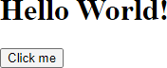

After Button click:

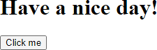

Results:

Thus, the above Program to Manipulate Web Page using JQuery was executed successfully.

Different Events of a Web Page using JQuery

Source Code:

<!DOCTYPE html>
<html>
<head>
<script src="https://code.jquery.com/jquery-3.6.0.min.js"></script>
</head>
<body>
<h1>Hello World!</h1>

<script>
$(document).ready(function () {
$("h1").click(function () {
$(this).hide();
});
$("h1").hover(function () {
$(this).css("background-color", "yellow");
});
$("h1").mousedown(function () {
$(this).css("background-color", "red");
});
});
</script>
</body>
</html>

Output:





Results:

Thus, the above Program to Different Events of a Web Page using JQuery was executed successfully.

Different Effects using JQuery

Source Code:

<!DOCTYPE html>
<html>
<head>
<script src="https://ajax.googleapis.com/ajax/libs/jquery/3.6.3/jquery.min.js"></scrip t>
<script>
$(document).ready(function () {
$(".btn1").click(function () {
$("p").slideUp();
});
$(".btn2").click(function () {
$("p").slideDown();
});
});
</script>
</head>
<body>
<p>This is a paragraph.</p>
<button class="btn1">Slide up</button>
<button class="btn2">Slide down</button>
</body>
</html>

Output:
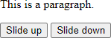

Results:

Thus, the above Program to Different Effects using JQuery was executed successfully.

